Technical Project Team

VMWare – Utilize VMWare Converter for VM Migrations to vSphere

SOP

PREPARED BY
Kelvin Aruin – Senior Technical Project Engineer

TABLE OF CONTENTS
Pre-Requisites 3
Create a Provisioning Package 4

User VMWare Converter to migrate a server (physical or virtual) to vCenter or vSphere

  - Utilize INC / Take control and log on to the machine that is to be migrated.
  - Download and install the VMWare Converter 6.2.0 executable.
  - Use the default options during the installation, such as local installation as shown below:
    - 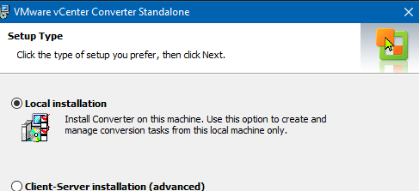
  - Restart the server.
  - Turn off any services that may interfere with the migration (SQL, etc.)
  - Turn off Windows firewall, User Access Control (UAC), and Anti-Virus, if possible.
  - Create a maintenance window for this server in INC.
  - Make sure you have a good and current backup of your server.
  - Create a checkpoint or snapshot of your server, if possible.
  - Log into the Datto Portal and pause Datto backups (cloud and local) for this server.
  - Send an email to the client/parties involved informing them of the migration start.
  - Launch the VMWare converter.
  - In the Administration menu, click on Data Connections Per Task and set it to Maximum.

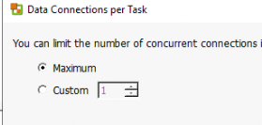
  - Click on ‘Convert Machine’ and then select ‘Powered on’ and ‘This local machine’.
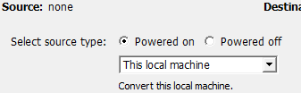

  - Press ‘Next’, then fill out the Vcenter server information (IP, username, and password).
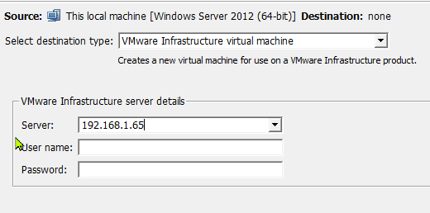
  - IF a certificate alert pops up, press the ‘Ignore’ button.
  - Press ‘Convert’.
  - You should see the job start and the task field populate with some information regarding ETA and percentage completed as the job should have started:
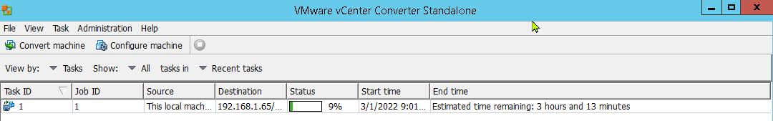
  - Once the machine is done converting, before starting on the Vcenter side make sure you disable the NIC on the source server.
  - Copy the source server MAC address and assign it to the NIC on the destination server.
  - Turn off the source server and turn on the destination server.
  - Check to make sure the correct IP has been applied to the copy, if not you will have to set it manually.
  - Make sure services that are set to auto or auto delayed are all running.
  - Resume backups
  - Send out an email to the client and any parties involved, informing them of migration completion.

